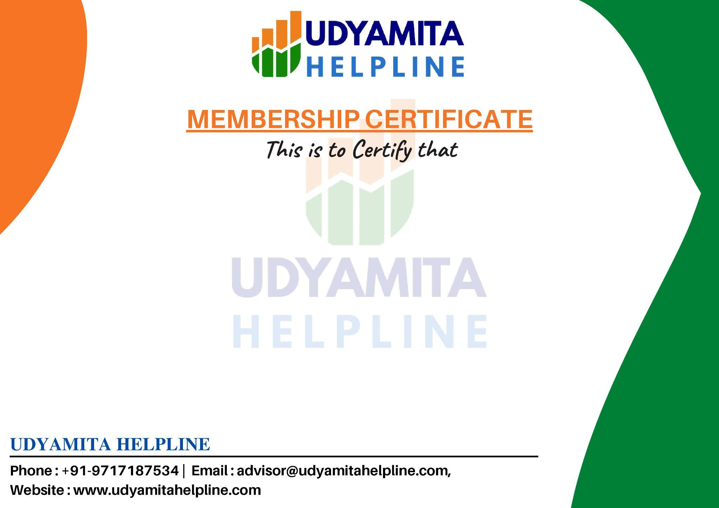

M/s Sourabh Sharma
is a proud member of
Udyamita Helpline
for the period Jan 2025 - Oct 2025

Date : 22-10-2025
Membership No.: MEM123456

